## **Commit Message Standards**

After cloning, please run **git-setup.sh**. It is located in the root of the git repository. This will set up the commit template for your new repository.

When performing a 'git commit' command, you will be provided with a template for which you may fill in. The key points to remember are:

* The first line of a commit message you should try to keep around 50 characters or less. The maximum for this line is 70-75 characters, while it is challenging to be both succinct and descriptive, that is what a well-written summary should do.
* Follow with a blank line, then
* Remaining text should be wrapped at 72 characters except for quoted material that has a specific line format. (The exception refers mainly to "non-prose" text, i.e. text not written by a human for the commit: eg, compiler error messages.)

We'll do the manual wrapping because git's log does not automatically wrap, making logs hard to read if they're too long.

## **Git Branch Standards**

#### **Branching Model**

Our model is greatly inspired by [this model](http://nvie.com/files/Git-branching-model.pdf), however; it does not include hotfix branches as that seems out of scope for us.

Our model: 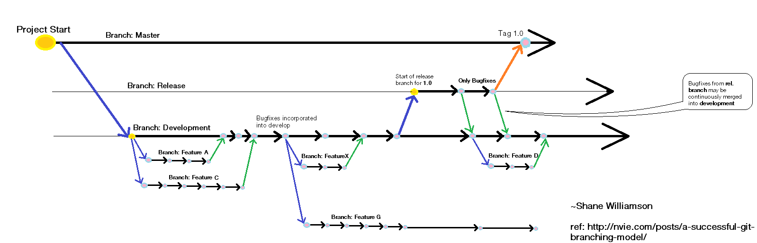

#### **Branch Naming Conventions**

**Feature branches**

* Anything except master, development, or release-*

**Release branches**

* release-* *(e.g. "release-1.0")*

## **Git Cheat Sheet**

Cheat sheet for good git usage 